**CSCI 5333 – Database Management System**

**Professor: Dr. Khondker Shajadul Hasan**

**FINAL REPORT**

**On**

**PHARMACY MANAGEMENT SYSTEM**

**By:**

Mohammed Zain Badal: 2304618

Nirupama Anandakrishnan: 2309496

Krupa Balaraj: 2310256

**TABLE OF CONTENTS**

|  |  |  |
| --- | --- | --- |
| **S.No** | **Content** | **Page No.** |
| 1 | Abstract | 1 |
| 2 | Introduction | 2 |
| 3 | Purpose of work | 3 |
| 4 | System configuration | 4 |
| 5 | Database design | 5 |
| 6 | Dataflow diagram | 10 |
| 7 | Use case diagram | 11 |
| 8 | ER diagram | 12 |
| 9 | Schema diagram | 13 |
| 10 | Relational schema | 14 |
| 11 | Entity set designation | 15 |
| 12 | Reducing to empty tables | 17 |
| 13 | Interface design | 19 |
| 14 | Output | 20 |
| 15 | Contribution | 27 |

**LIST OF TABLES**

|  |  |  |
| --- | --- | --- |
| **Table No** | **Contents** | **Page No** |
| 5.1 | Admin | 5 |
| 5.2 | Manager | 5 |
| 5.3 | Cashier | 6 |
| 5.4 | Pharmacist | 6 |
| 5.5 | Customer | 7 |
| 5.6 | Prescription | 7 |
| 5.7 | Stock | 8 |
| 5.8 | Invoice | 8 |
| 5.9 | Invoice details | 9 |
| 5.10 | Receipts | 9 |
| 5.11 | Pays | 9 |

**LIST OF FIGURES**

|  |  |  |
| --- | --- | --- |
| **Figure No** | **Contents** | **Page No** |
| 6.1 | Dataflow diagram | 10 |
| 7.1 | Use case diagram | 11 |
| 8.1 | ER diagram | 12 |
| 9.1 | Schema diagram | 13 |
| 13.1 | User login page | 19 |
| 14.1 | Admin login page | 20 |
| 14.2 | Manage pharmacist detail | 20 |
| 14.3 | Add pharmacist | 21 |
| 14.4 | Manage manager detail | 21 |
| 14.5 | Add manager | 22 |
| 14.6 | Manage cashier detail | 22 |
| 14.7 | Add cashier page | 23 |
| 14.8 | View prescription page | 23 |
| 14.9 | View stock page | 24 |
| 14.10 | Add stock page | 24 |
| 14.11 | Prescription creating page | 25 |
| 14.12 | Receipt creation page | 25 |
| 14.13 | Payment page | 26 |

**ABSTRACT**

A Pharmacy Management System streamlines operations by providing instant access to medicine details upon entering their names. This computerized system offers information such as medication prices, expiry dates, and storage locations, significantly simplifying tasks in large medical stores where manual record-keeping becomes challenging.

This system efficiently keeps track of medicine data, updating it whenever new stock arrives and specifying precise storage locations. It promptly retrieves medicine details upon query, including pricing, expiry alerts, and storage locations.

Previously were dependent on manual processes, pharmacies required frequent checks by assistants to monitor expiry dates and stock shortages. Expired medications were kept apart for safety, while stock deficits prompted pharmacists to fill purchase orders manually.

Overall, the Pharmacy Management System enhances efficiency by automating record-keeping, ensuring accurate medication details, and facilitating timely actions regarding expiry and restocking. It also ensures productivity.

**INTRODUCTION**

Apart from the fundamental functions of inventory management, this user-friendly Pharmacy Management System has the potential to completely transform the pharmaceutical industry by including a variety of features that increase accuracy as well as effectiveness.

One of its main objectives is simplifying the medicine distribution process and enabling pharmacists to quickly and easily obtain essential information. This system makes it possible to quickly and precisely identify medications, modify dosages, and efficiently receive and remove medication batches by providing a centralized database of medication data.

Additionally, this system is more than just a database; it's an easy-to-use tool that helps pharmacists make better decisions. It enables quick access to particular medications by keeping thorough medication records, ensuring that patients receive the appropriate drug at the appropriate time, and reducing medication delivery mistakes.

Furthermore, the system includes effective error-checking procedures since it understands how important data accuracy is. It reduces the possibility of data entry errors across several pharmacy sites with user-friendly interfaces and error alerts, promoting reliability and precision in pharmaceutical operations.

Ultimately, this Pharmacy Management System is an innovative solution that transforms drug data handling, inventory optimization, and providing amazing patient care by integrating technological innovation with a user-centric design.

This pharmacy management system is a comprehensive strategy not only tackles the problems facing the pharmaceutical industry today, but also paves the way for a future in healthcare that is more effective, error-free, and patient-focused.

**PURPOSE OF WORK**

Automating a pharmacy system's management addresses important issues embedded in conventional manual processes, not just modernizing operations. Its main objective goes far beyond process simplification; it is a good attempt to improve healthcare services by increasing patient satisfaction and dependable healthcare delivery.

The main motivation is to automate the process carried out for managing the pharmacy system. The manual process is more prone to error and is also a time-consuming process. The paperwork process needs to be maintained well and retrieving the medication details, location, expiry date, and other details needs effort and is a big burden. This workload can be simplified using the pharmacy management system.

This system can provide accurate date information on the inventory so that it helps in managing the medicines safely preventing the storage of expired stock and ensuring shortage of stocks. The system not only refines the tasks it also motivates to add on more features to increase the efficiency to have quick access to important data.

Additionally, the pharmacy system also helps in improving the service provided to the customers. It works to make sure that patients get the right drugs at the right times, in the right quantity, and at the right doses. Overall, they introduce paperless processes, and faultless processes, and focus on satisfying patients with reliable healthcare.

**4. SYSTEM CONFIGURATION**

**OVERALL SYSTEM’S DATA REQUIREMENTS:**

To run the pharmacy management project, we need the following requirements:

**HARDWARE REQUIREMENTS:**

* Processor: Intel i5 onwards
* Memory: 8.00 GB RAM
* Hard Disk Space: 100GB

**SOFTWARE REQUIREMENTS:**

* Front end: php (Version 7.2.34)
* Back end: PostgreSQL (Version 12.17)
* Server: XAMPP (Version 7.2.34)

**5. DATABASE DESIGN**

**Table 5.1: Admin**

|  |  |  |
| --- | --- | --- |
| **Column Name** | **Data Type** | **Description** |
| admin_id | Domain ID | Primary Key and ID for admin |
| username | varchar | Login credential of admin |
| password | varchar | Login credential of admin |
| date | date | Date of admin account creation |
| local_address | Domain address | Address of admin |
| email | Domain email_validate | Email address of the admin |
| Phone_number | Domain number_check | Phone number of admin |

**Table 5.2: Manager**

|  |  |  |
| --- | --- | --- |
| **Column Name** | **Data Type** | **Description** |
| manager_id | Domain ID | Primary Key and ID for manager |
| first_name | varchar | First name of manager |
| last_name | varchar | Last name of manager |
| postal_address | Domain address | Manager’s postal address |
| Phone | Domain number_check | Manager's phone number |
| Email | Domain email_validate | Email address of the manager |
| Username | varchar | Login credential manager |
| Password | varchar | Login credential manager |
| Date | date | Manager account created date |

**Table 5.3: Cashier**

|  |  |  |
| --- | --- | --- |
| **Column Name** | **Data Type** | **Description** |
| cashier_id | Domain ID | Primary Key |
| first_name | varchar | First name of the cashier |
| last_name | varchar | Last name of cashier |
| postal_address | Domain address | Postal address of the cashier |
| email | Domain email_validate | Email address of the cashier |  |  |
| phone | Domain number_check | Phone number of cashier |  |  |
| Username | varchar | Login credential of cashier |  |  |
| Password | varchar | Login credential of cashier |  |  |
| date | date | Date created |  |  |

**Table 5.4: Pharmacist**

|  |  |  |
| --- | --- | --- |
| **Column Name** | **Data Type** | **Description** |
| pharmacist_id | Domain ID | Primary Key |
| first_name | varchar | First name of pharmacist |
| last_name | varchar | Last name of pharmacist |
| postal_address | varchar | Postal address of the pharmacist |  |  |
| Phone | varchar | Phone number of the pharmacist |
| Email | varchar | Email of pharmacist |
| Username | varchar | Login credential pharmacist |
| Password | varchar | Login credential pharmacist |
| Date | date | Date created |

**Table 5.5: Customer**

|  |  |  |
| --- | --- | --- |
| **Column Name** | **Data Type** | **Description** |
| customer_id | Domain ID | Id of customer |
| customer_name | varchar | Name of customer |
| Age | varchar | Age of customer |  |  |
| Sex | varchar | Sex of customer |  |  |
| postal_address | varchar | Postal address of the customer |  |  |
| Phone | varchar | Phone Number |  |  |

**Table 5.6: Prescription**

|  |  |  |
| --- | --- | --- |
| **Column Name** | **Data Type** | **Description** |
| Pres_id | Domain ID | Primary Key |
| Dose | varchar | Dose of medicine |  |  |
| Quantity | int | Quantity of medicine |  |  |

**Table 5.7: Stock**

|  |  |  |
| --- | --- | --- |
| **Column Name** | **Data Type** | **Description** |
| Stock_id | Domain ID | Primary Key |
| drug_name | varchar | Name of drug |
| Category | varchar | Category |
| Description | varchar | Description about stock |
| Company | varchar | Related company |  |  |
| Supplier | varchar | Supplier Detail |  |  |
| Quantity | varchar | Quantity Left |  |  |
| Cost | varchar | Cost of drug |  |  |
| Status | Domain status | Status of availability |  |  |
| Date_supplied | date | Date of supplied |

**Table 5.8: Invoice**

|  |  |  |
| --- | --- | --- |
| **Column Name** | **Data Type** | **Description** |
| invoice_id | Domain ID | Primary Key for invoice |
| date | date | Date of the generated invoice |

**Table 5.9: Invoice_details**

|  |  |  |
| --- | --- | --- |
| **Column Name** | **Data Type** | **Description** |
| invoice_id | Domain ID | Primary Key for invoice details |
| dose | varchar | Dosage of drugs |
| cost | Domain amt_validate | Total amount |
| quantity | Domain amt_validate | No of items |

**Table 5.10: Receipts**

|  |  |  |
| --- | --- | --- |
| **Column Name** | **Data Type** | **Description** |
| Receiptno | Domain ID | Primary Key |
| Total | Int | Total amount |
| Date | timestamp | Date of receipt given |  |  |

**Table 5.11: Pays**

|  |  |  |
| --- | --- | --- |
| **Column Name** | **Data Type** | **Description** |
| Pay_id | Domain ID | Primary Key |
| Payment_type | varchar | Mode of payment |
| amt | varchar | Amount to pay |

**6. DATAFLOW DIAGRAM**

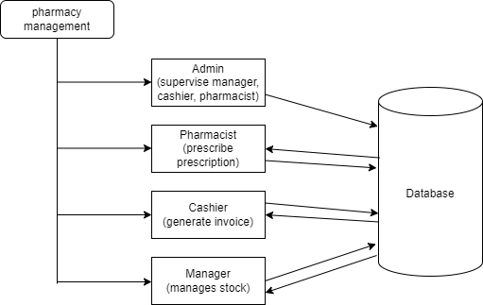

Figure 6.1: Dataflow diagram

**7. USE CASE DIAGRAM**

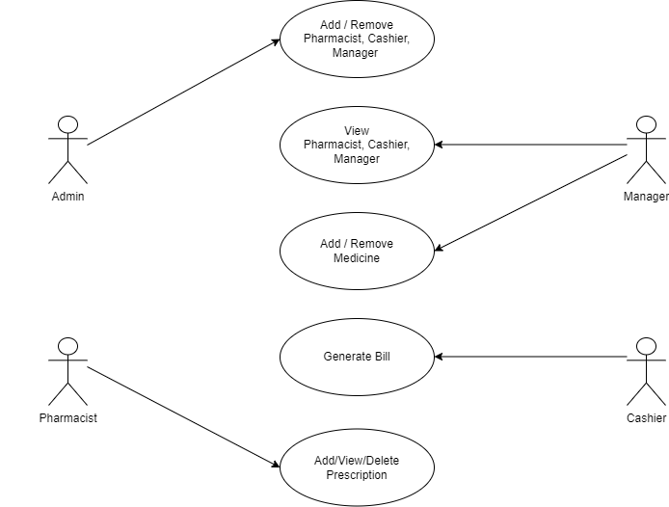

Figure 7.1: Use case diagram

**8. ER DIAGRAM**

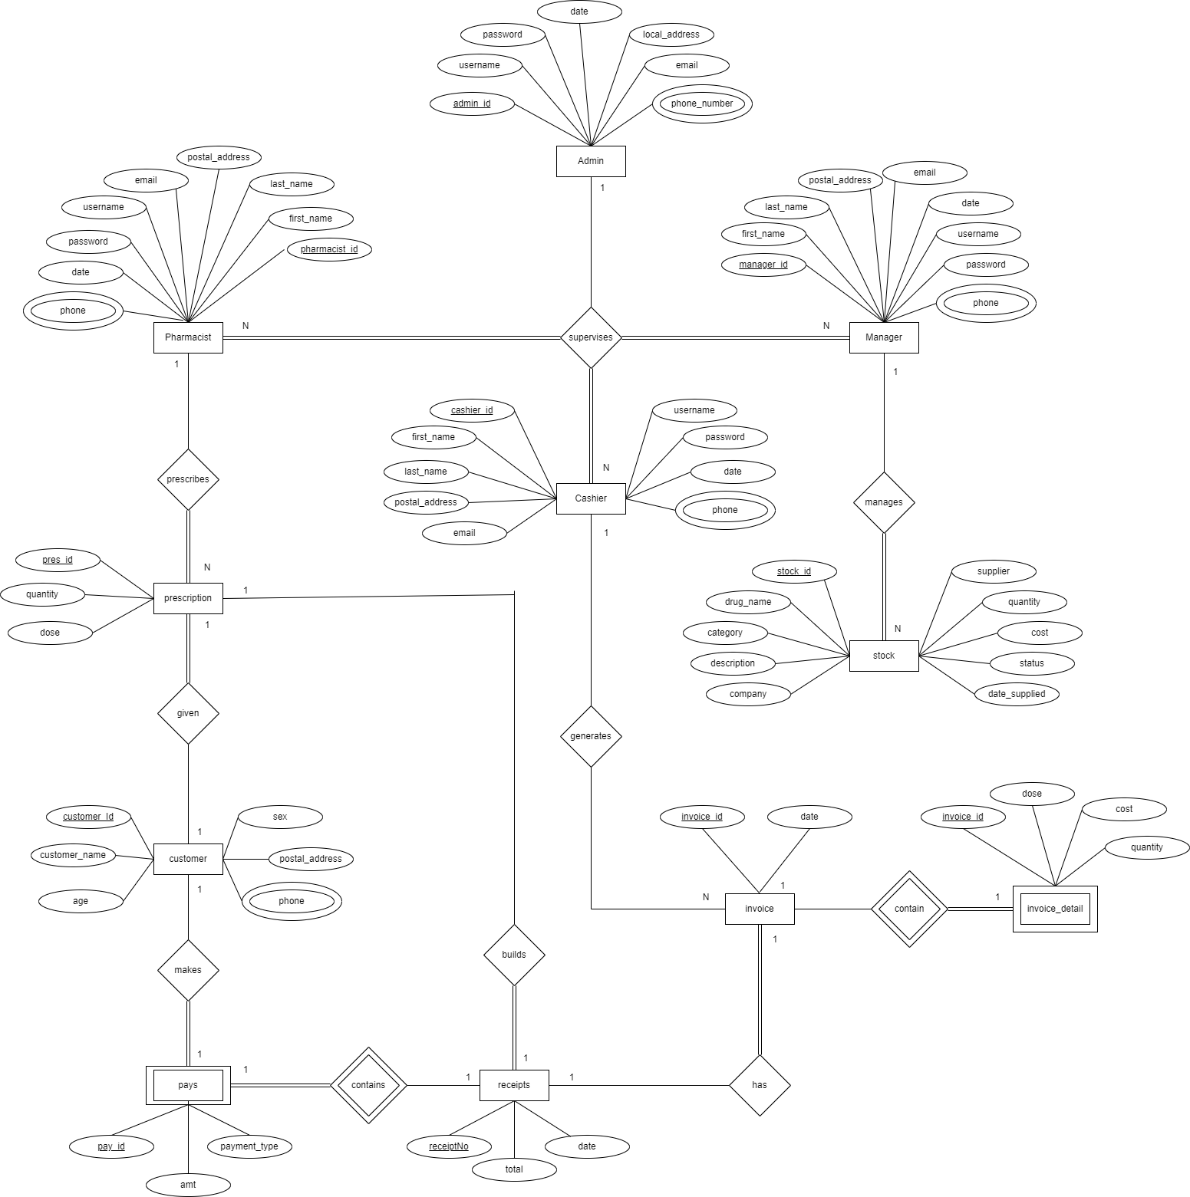

Figure 8.1: ER diagram

**Assumptions:**

1. A customer can make a payment for a receipt.
2. An invoice has an invoice detail.
3. A pharmacist can generate many prescriptions for a customer.
4. An admin can supervise many users (pharmacist, cashier, manager).

**9. SCHEMA DIAGRAM**

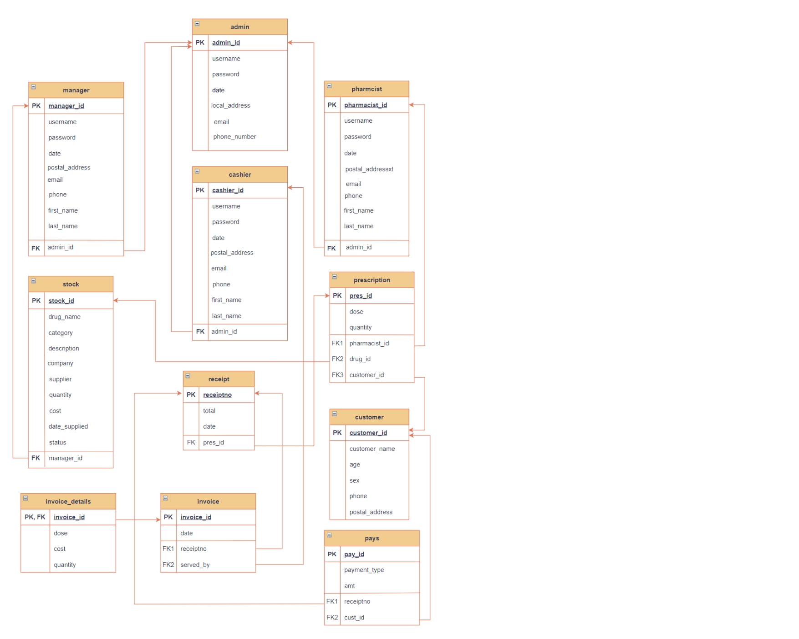

Figure 9.1 Schema diagram

**10. RELATIONAL SCHEMA**

admin = (admin_id, username, password, date, local_address, email, phone_number)

cashier = (cashier_id, first_name, last_name, postal_address, phone, email, username, password, date, admin_id)

pharmacist = (pharmacist_id, first_name, last_name, postal_address, phone, email, username, password, date, admin_id)

manager = (manager_id, first_name, last_name, postal_address, phone, email, username, password, date, admin_id)

stock = (stock_id, drug_name, category, description, company, supplier, quantity, cost, status, date_supplied, manager_id)

customer = (customer_id, customer_name, age, sex, postal_address, phone)

prescription = (pres_id, drug_id, dose, quantity, pharmacist_id, customer_id)

invoice = (invoice_id, receiptno, served_by, date)

invoice_details = (invoice_id, dose, cost, quantity)

receipts = (receiptno, total, date, pres_id)

pays = (pay_id, payment_type, amt, receiptno, cust_id)

[Note:]

Primary key:

Foreign key:

**11. ENTITY SET DESIGNATION**

* Admin {{ Admin_Id, Admin’s ID },{ Username, Admin’s Username}, { Password, Admin’s Password}, { Date, Admin’s Creation Date}, {Email, Admin’s Email Id}, {Phone_number, Admin’s Phone Number}, {Local_address, Admin’s Address}}
* Pharmacist {{Pharmacist_Id, Pharmacist’s ID},{ Username, Pharmacist’s Username}, { Password, Pharmacist’s Password}, {First Name, Pharmacist’s First_Name},{ Last_Name, Pharmacist’s Last_Name}, {Email, Pharmacist’s Email Id}, {Phone, Pharmacist’s Phone Number}, {Postal_address, Pharmacist’s Address}}, { Date, Pharmacist’s Creation Date}, {Admin_Id, Admin’s ID}}
* Cashier {{Cashier_Id, Cashier’s ID}, {Username, Cashier’s Username}, { Password, Cashier’s Password}, {First Name, Cashier’s First_Name},{ Last_Name, Cashier’s Last_Name}, {Email, Cashier’s Email Id}, {Phone, Cashier’s Phone Number}, {Postal_address, Cashier’s Address}}, { Date, Cashier’s Creation Date}, {Admin_Id, Admin’s ID}}
* Manager {{Manager_Id, Manager’s ID}, {Username, Manager’s Username},{Password, Manager’s Password},{First_Name, Manager’s First_Name},{Last_Name, Manager’s Last_Name},{Postal_address, Manager’s Address},{Phone, Manager’s Phone number},{Email, Manager’s Email ID}, { Date, Cashier’s Creation Date}, {Admin_Id, Admin’s ID}}
* Stock {{Stock_Id, Stock’s ID},{Drug_Name, Drug’s Name},{Supplier, Drug’s Supplier Name},{Quantity, Drug Quantity},{Company, Drug’s Company Name},{Status, Supplying Status},{Category, Drug’s Category},{Description, Description about drug},{Cost, Drug’s Cost},{Date_Supplied, Drug Supply Date}}, {Manager_Id, Manager’s ID}}
* Prescription {{Pres_id, Prescription’s ID}, {Drug_Id, Stock’s ID}, {Dose, Drug’s Dosage}, { Quantity, Drug Quantity}, {Pharmacist_Id, Pharmacist’s ID}, {Customer_Id, Customer’s ID}}
* Invoice {{Invoice_id, Invoice’s ID}, {Receiptno, Receipt’s ID}, {Served_by, Cashier’s ID}, { Date, Invoice Creation Date}}

* Invoice_details {{Invoice_id, Invoice’s ID}, {Dose, Drug’s Dosage}, {Cost, Drug’s ID}, {Quantity, Drug’s Quantity}}
* Receipts {{Receiptno, Receipt’s ID}, {Total, Drug’s Total Amount}, { Date, Receipt’s Creation Date}, {Pres_id, Prescription’s ID}}
* Pays {{Pay_id, Payment’s ID}, {Receiptno, Receipt’s ID}, {Payment_type, Type of Payment}, { Amt, Total Amount}, {Cust_id, Customer’s Id}}
* Customer { {Customer_id, Customer’s Id}, {Customer_name, Name of Customer}, { Age, Customer’s Age}, { Sex, Customer’s Gender}, {Postal_address, Customer’s Address}, {Phone, Customer’s Phone Number}}

**12. REDUCING TO EMPTY TABLES**

**ADMIN**

|  |  |  |  |  |
| --- | --- | --- | --- | --- |
| Admin_id | Username | Password | Date | Email |
| Phone_number | Local_address |

**PHARMACIST**

|  |  |  |  |  |
| --- | --- | --- | --- | --- |
| Pharmacist**­­**_id | Username | Password | First_Name | Last_Name |
| Email | Phone | Date | Postal_address | Admin_ID |

**CASHIER**

|  |  |  |  |  |
| --- | --- | --- | --- | --- |
| Cashier_id | Date | Username | Password | First_name |
| Last_name | Postal_address | Phone | Email | Admin_ID |

**MANAGER**

|  |  |  |  |  |
| --- | --- | --- | --- | --- |
| Manager_id | Date | Username | Password | First_name |
| Last_name | Postal_address | Phone | Email | Admin_ID |

**STOCK**

|  |  |  |  |  |  |
| --- | --- | --- | --- | --- | --- |
| Stock_id | Manager_id | Drug_Name | Supplier | Quantity | Company |
| Status | Category | Description | Cost | Date_Supplied |

**PRESCRIPTION**

|  |  |  |  |  |  |
| --- | --- | --- | --- | --- | --- |
| Pres_Id | Pharmacist_id | Customer_id | Dose | Drug_id | Quantity |

**RECEIPTS**

|  |  |  |  |
| --- | --- | --- | --- |
| Receiptno | Pres_id | Total | Date |

**CUSTOMER**

|  |  |  |  |  |  |
| --- | --- | --- | --- | --- | --- |
| Customer_id | Postal_address | Customer_Name | Age | Sex | Phone |

**INVOICE**

|  |  |  |  |
| --- | --- | --- | --- |
| Invoice_Id | Receiptno | Served_by | Date |

**INVOICE_DETAILS**

|  |  |  |  |
| --- | --- | --- | --- |
| Invoice_Id | Dose | Cost | Quantity |

**PAYS**

|  |  |  |  |  |
| --- | --- | --- | --- | --- |
| Pay_Id | Payment_type | Amt | Receiptno | Cust_id |

**13. INTERFACE DESIGN**

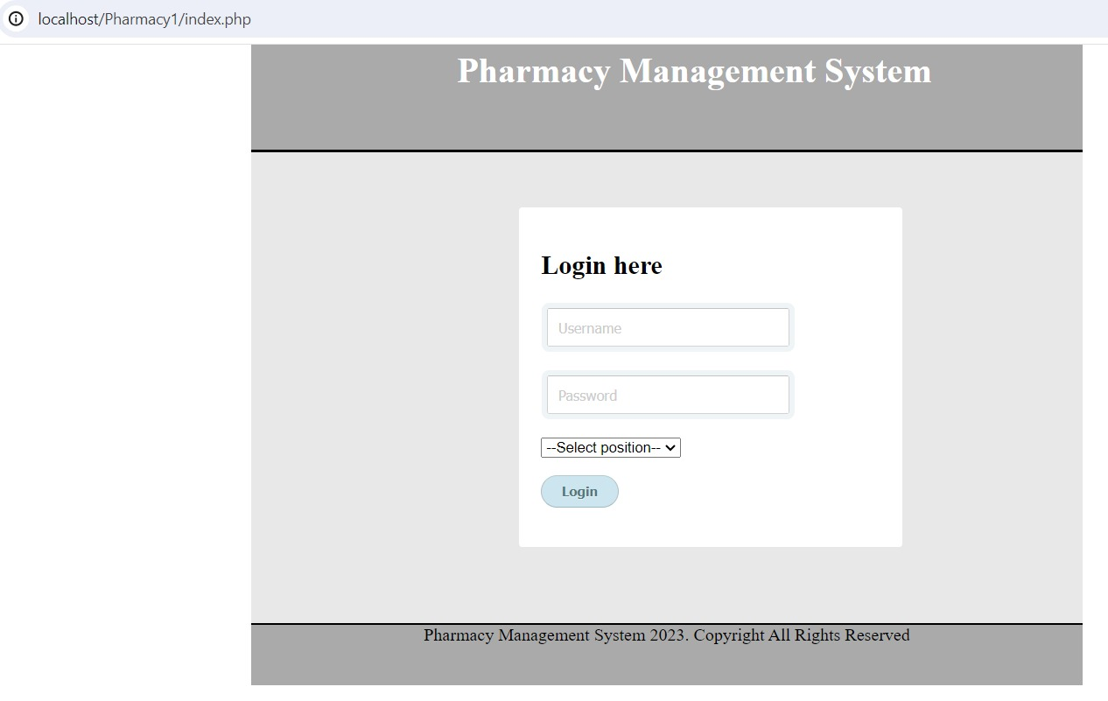

Figure 13.1: User login page

**14. OUTPUT**

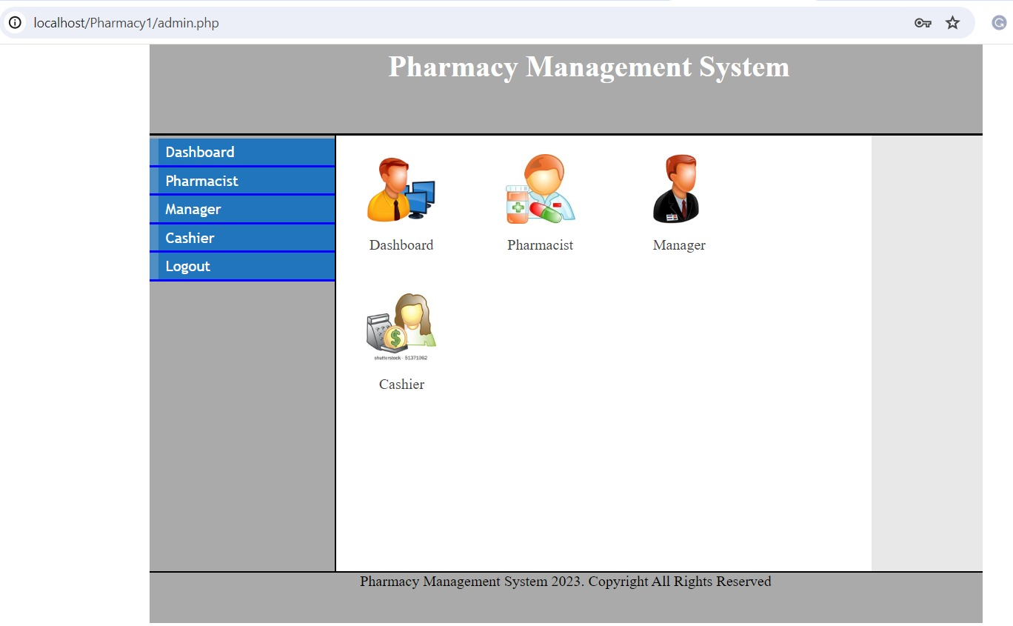

Figure 14.1: Admin Login Page

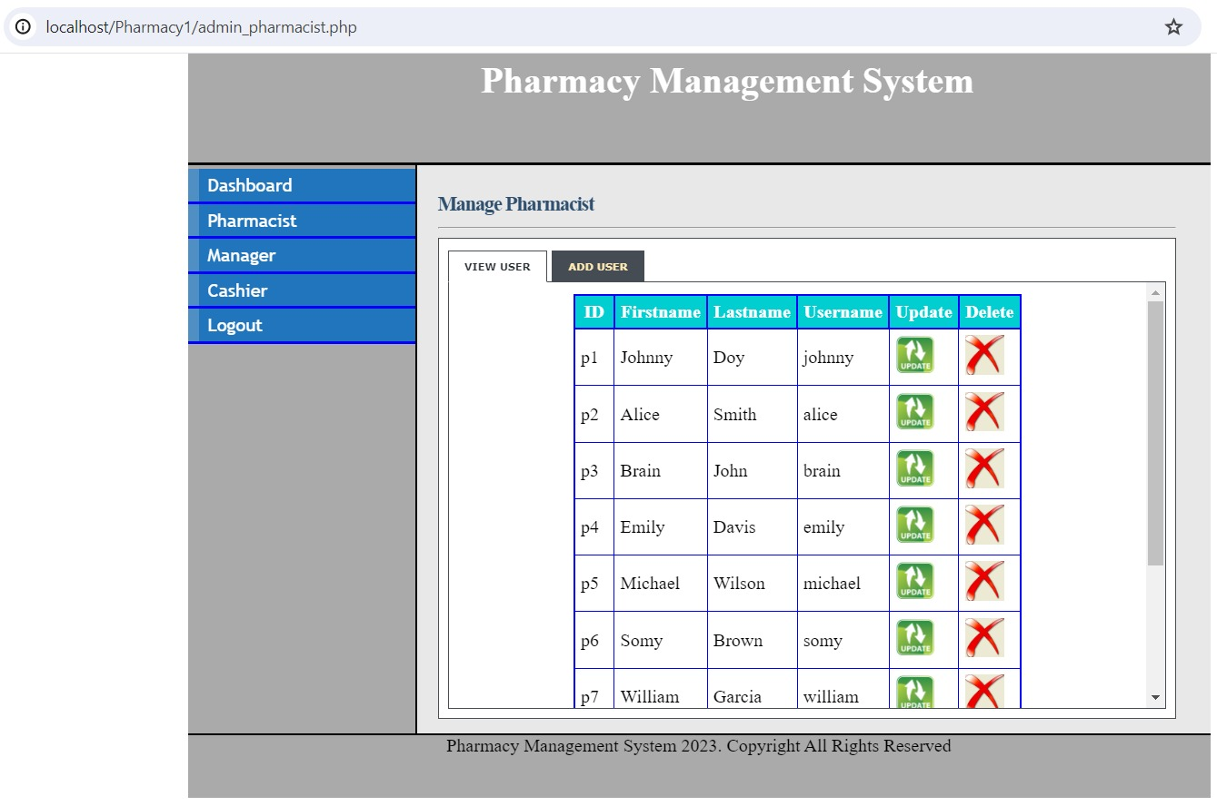

Figure 14.2: Manage Pharmacist Detail

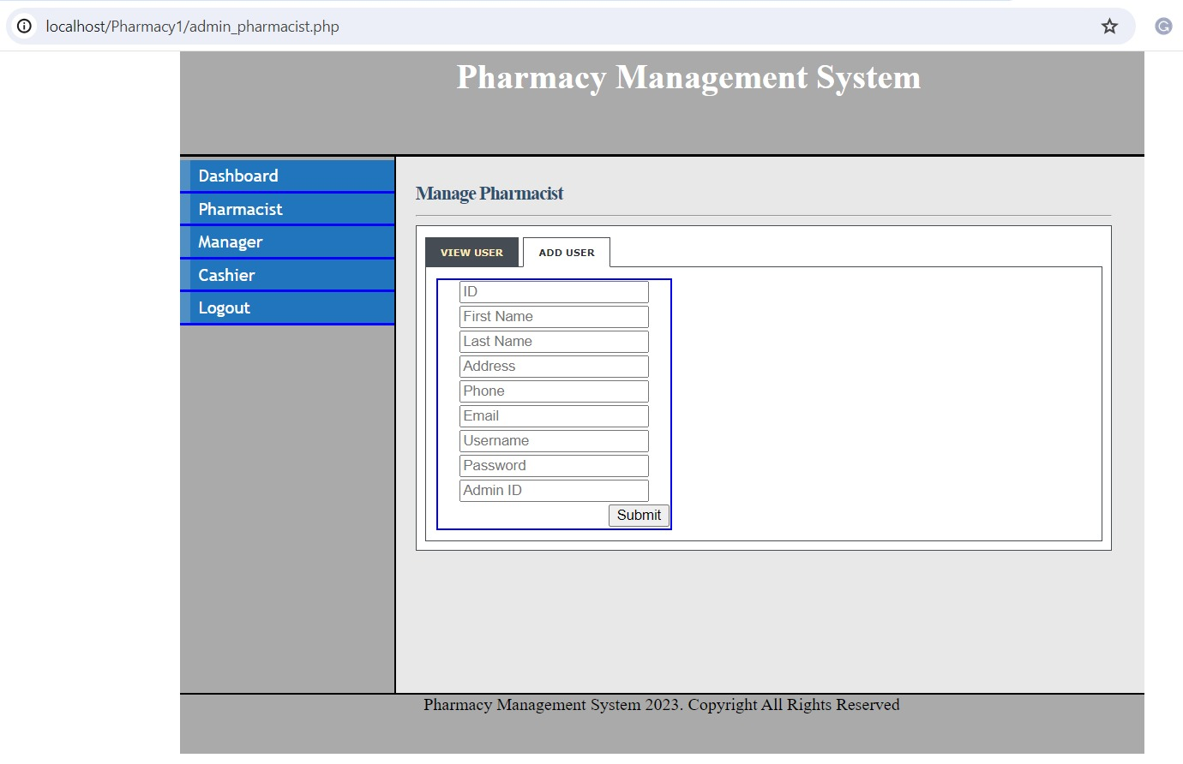

Figure 14.3: Add Pharmacist

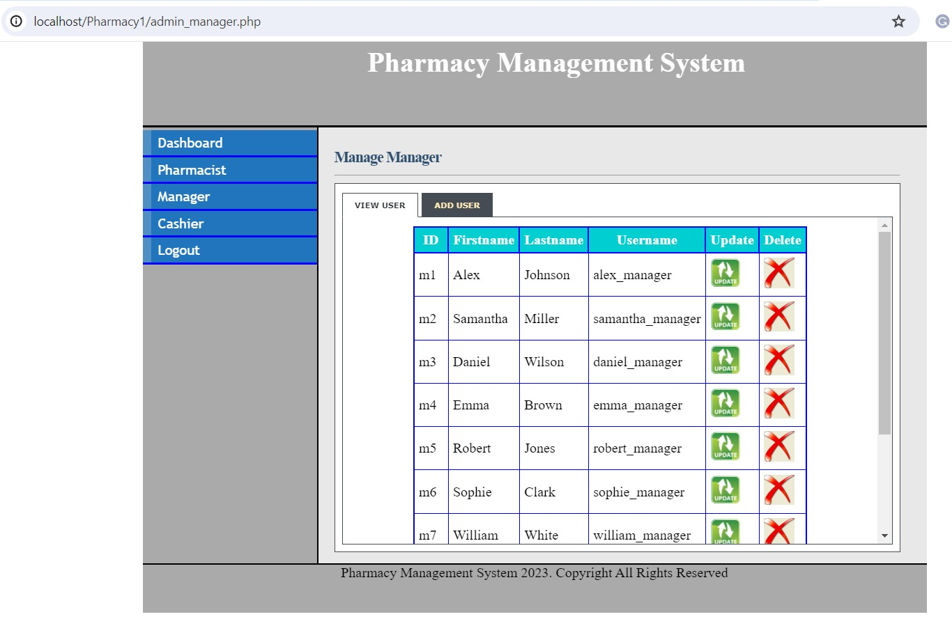

Figure 14.4: Manage Manager Detail

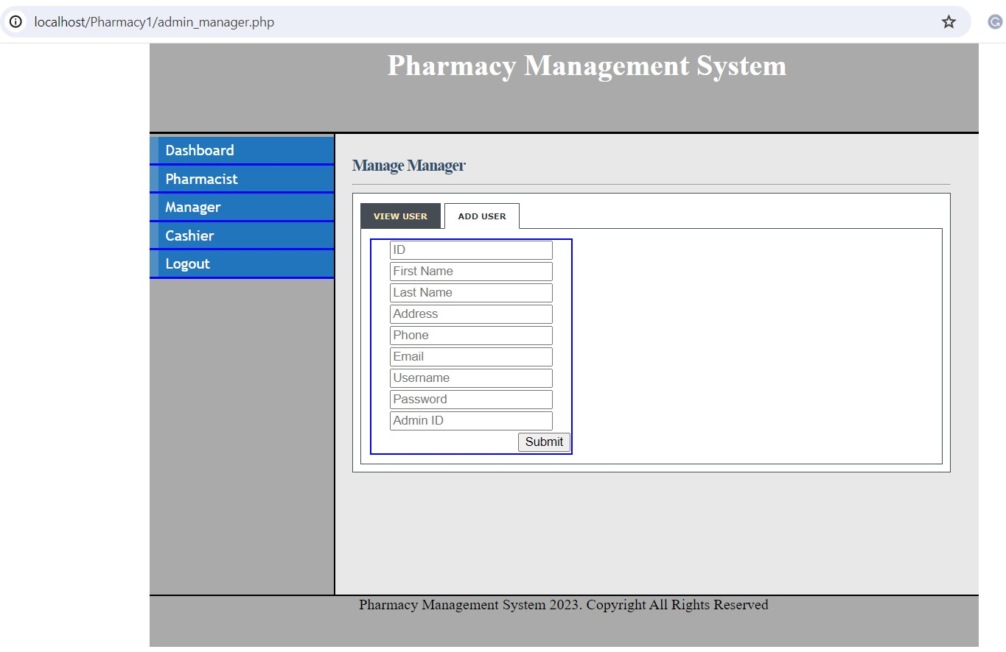

Figure 14.5: Add Manager

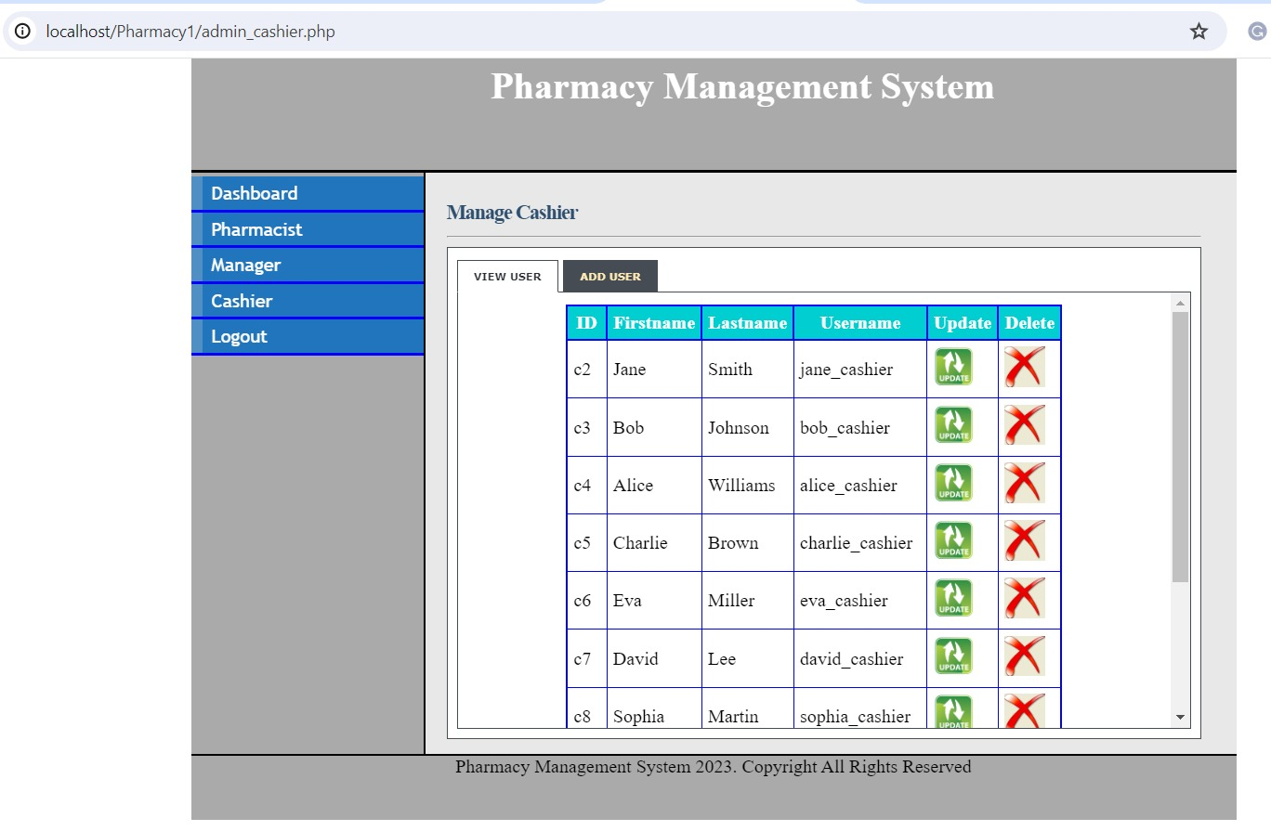

Figure 14.6: Manage Cashier Detail

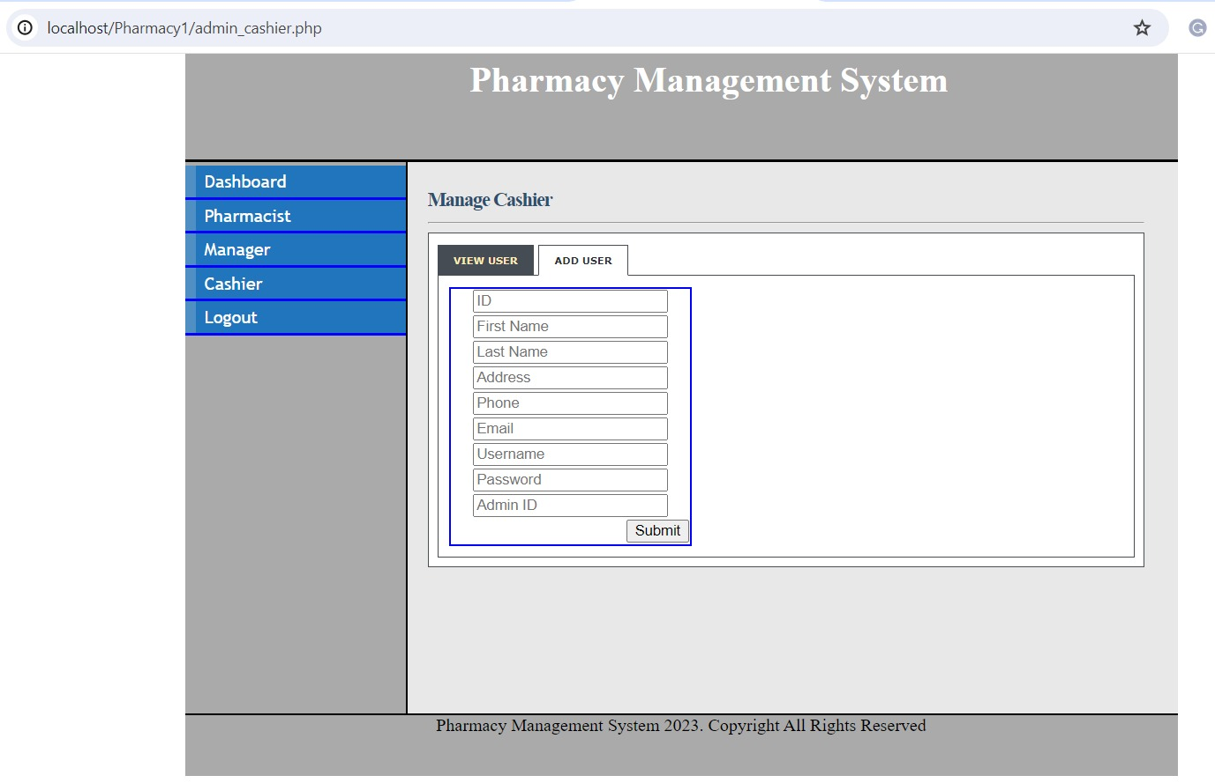

Figure 14.7: Add Cashier Page

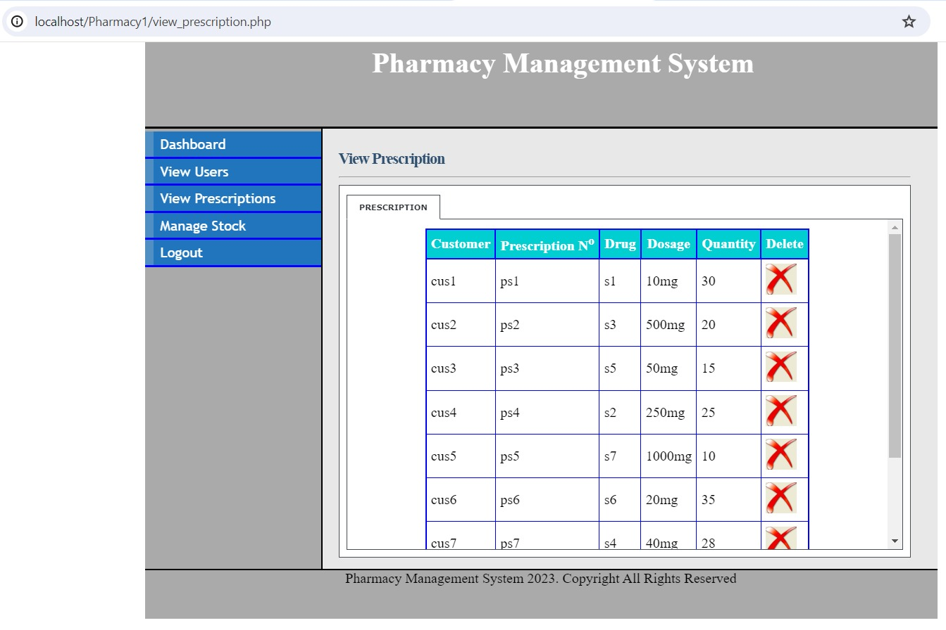

Figure 14.8: View Prescription page

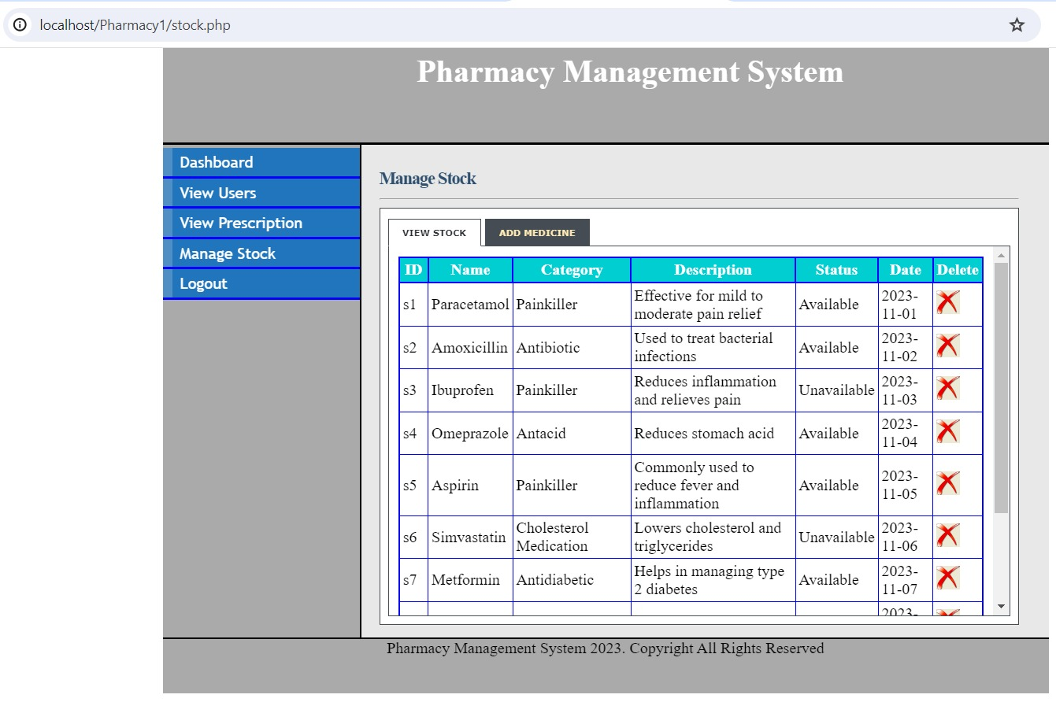

Figure 14.9: View Stock Page

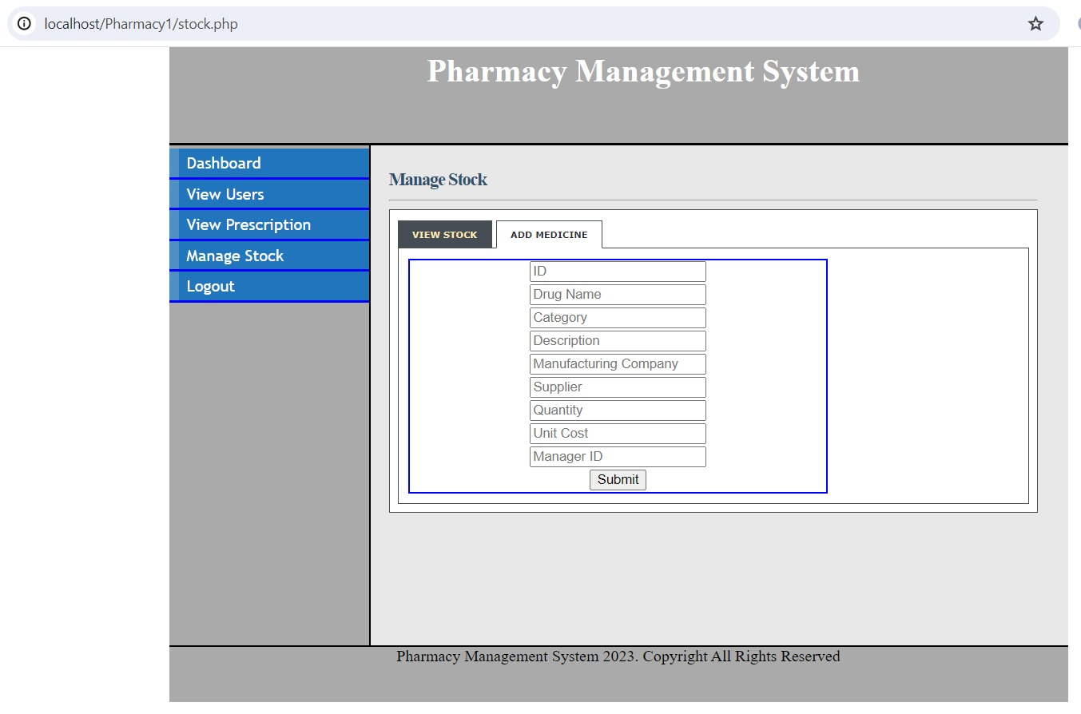

Figure 14.10: Add Stock Page

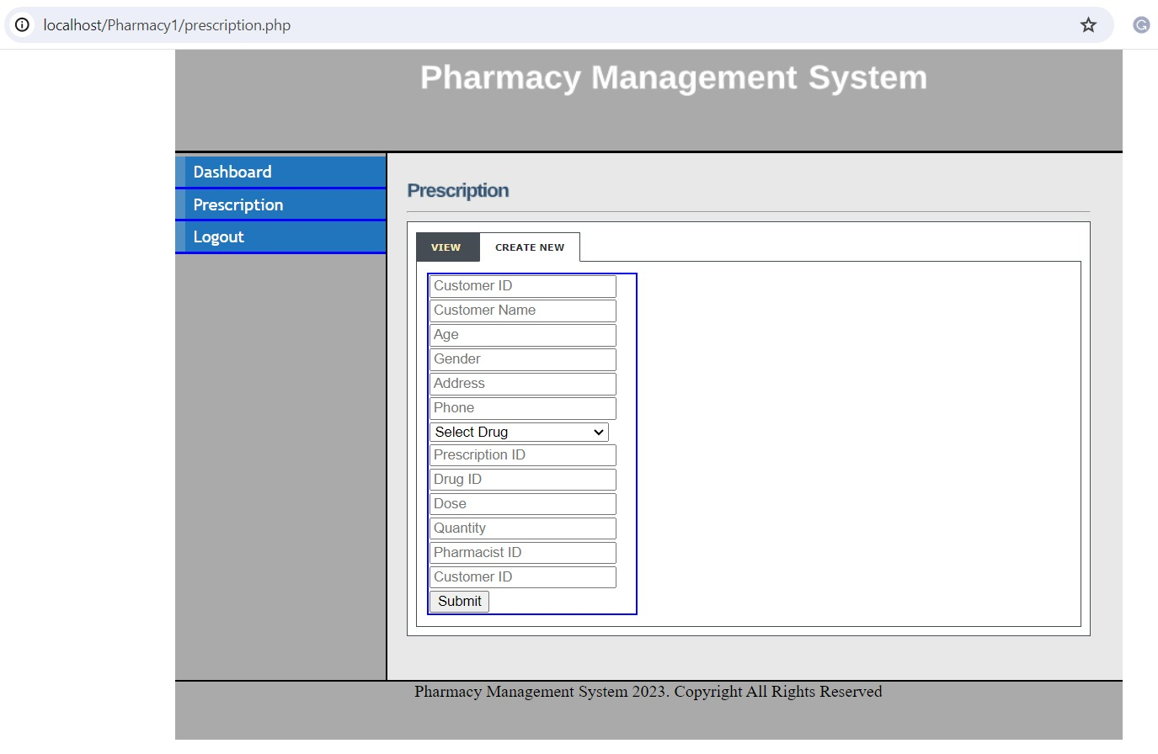

Figure 14.11: Prescription Creating Page

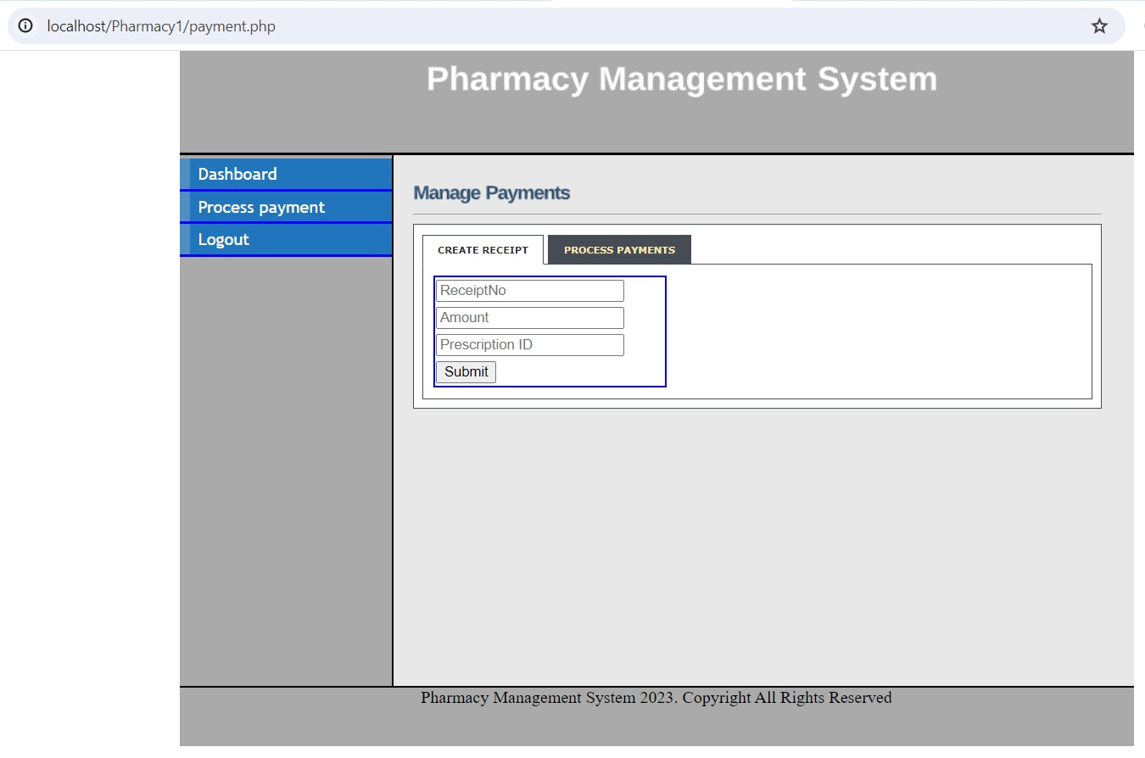

Figure 14.12: Receipt Creation Page

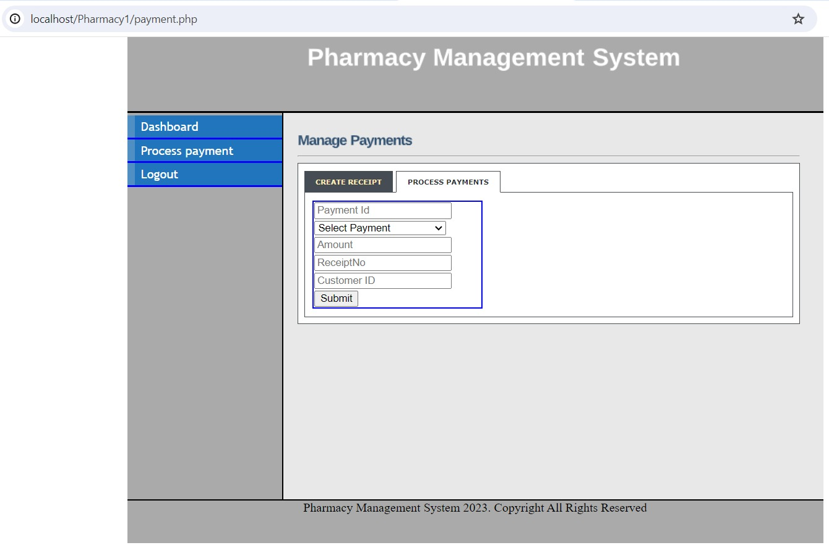

Figure 14.13: Payment Page

**15. CONTRIBUTION**

Krupa Balaraj: 2310256

Contributed towards developing PHP front end and building the database

Mohammed Zain Badal: 2304618

Contributed towards building the database and worked on final report documentation

Nirupama Anandakrishnan: 2309496

Contributed towards building the database and worked on final report documentation

**REFERENCES**

(1) **Ramez Elmasri, Shamkant B. Navthe. “Fundamentals of Database Systems” 7th Edition, Pearson.**

(2) **Robin Nixon. “Learning PHP, My SQL & JavaScript with JQuery, CSS & HTML5” 4th Edition, OREILLY.**

(3) [**https://www.enterprisedb.com/downloads/postgres-postgresql-downloads**](https://www.enterprisedb.com/downloads/postgres-postgresql-downloads)

(4) [**https://apache.org**](https://apache.org)

(5**)** [**https://freecodecamp.org**](https://freecodecamp.org)

(6) [**https://blog.udemy.com/xampp-tutorial/**](https://blog.udemy.com/xampp-tutorial/)

(7) [**https://www.sublimetext.com/**](https://www.sublimetext.com/)

(8) <https://www.youtube.com/watch?v=DFvBnsY15Bo>